Dalton Murray

Systems Analysis and Design

INT 4202 - 1952-202310_INT4203_M

Dr. Anthony Padalino

October 11, 2022

**Week 7 Assignment**

**What is object-oriented analysis, and what are some advantages of this method?**

Object-oriented analysis, O-O analysis, is defined by the book *Systems Analysis and Design* as “views the system in terms of objects that combine data and processes. The objects represent actual people, things, transactions, and events. Compared to structural analysis, O-O phases tend to be more interactive. Can use the waterfall model or a model that stresses greater iteration.” (Tilley, S. p. 18). In other words, object-oriented analysis is an approach of how we see a system, how we design and develop a system, and how we interact with a system. Object-oriented analysis is focused on using objects rather than seeing the system as data, and processes. There is also object-oriented diagramming to help creating the system as well as business process modelling.

According to the book, *Systems Analysis and Design,* some advantages of using object-oriented analysis are that it “integrates easily with object-oriented programming languages. Code is modular and reusable, which can reduce cost and development time. Easy to maintain and expand because new objects can be created using inherited properties” (Tilley, S. p. 18). In other words, some advantages of using object-oriented analysis over other methods such as structured analysis is that it integrates with object-oriented focused programming languages such as Python, allowing a programmer to be able to be more productive and efficient in design. It also is modular and reusable so you can make one object in the program and then call back to it with new inputs and get new data using the same functions rather than programming a new object which is going to do the same thing, this then reduces the amount of time the programmer must put into the program. It is also easier to maintain and more simplistic than other methods. On top of all of this, object-oriented analysis may easily integrate with the Unified Modeling Language, UML, to document and visualize an information system (Tilley, S. p. 181).

You can also see the main differences between object-oriented analysis and structured-analysis in the below 4 images. The first image shows a structured-analysis diagram which focuses on the flow of the data and processes, the image below shows an object-oriented diagram which shows the interaction of the objects, below that is the process of doing structured-analysis which uses a waterfall model and below that is the object-oriented process flow which allows tasks to occur simultaneously.

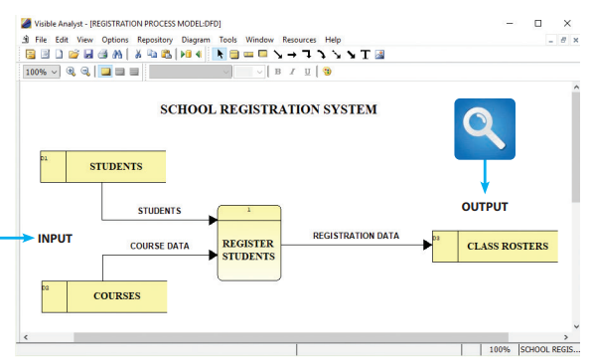

Structured-analysis example diagram

(Tilley, S. p. 19).

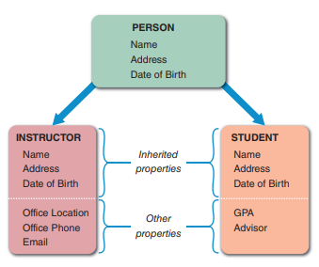

Object-oriented analysis example diagram

(Tilley, S. p. 22).

Structured analysis flow

(Tilley, S. p. 20).

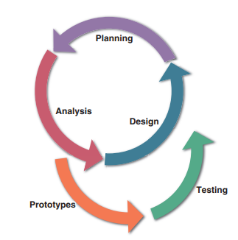

Object-oriented flow

(Tilley, S. p. 22).

**Define an object, and provide three examples.**

An object, according to the book *Systems Analysis and Design* “represents a real person, place, event, or transaction” (Tilley, S. p. 181). To try to explain it better in programming there are classes and a class can contain multiple instances of itself with different information, which is an object and has attributes about itself. Objects as they are an instance of a class may belong to other classes which inherit information or pass down attributes to them. Objects may also have methods or processes such as things they can do. Within objects they also can interpret things differently, which is polymorphism. Let’s say 3 objects get a message saying something like it’s time to eat, a person make interpret this and call a method to call out take out at a restaurant or delivery, or another person may interpret this to start cooking.

Let’s say that there is a class called car and within that class there are a lot of attributes such as make, model, year, and then there are instances of that class car which are objects. Let’s take for example a 2022 tesla model s plaid, those 3 things are its attributes, however, the entire thing is an object or an instance of the class. This object may also have its own methods such as being able to charge with electricity whereas other cars may have a method called fill up gas, or it may have other unique methods.

The book also gives an example of this, “For example, when a patient makes an appointment to see a doctor, the patient is an object, the doctor is an object, and the appointment itself is an object” (Tilley, S. p. 181). Looking into this example there is a patient, the patient itself has attributes such as name, age, health conditions and is an object or instance of a class such as patients, then there is a doctor which also has its own attributes like certifications, authorized care they can do, and is an object or instance of a class such as employees, then there is the appointment itself. We must look back at the definition of an object and see that a object can be a real person, place, event, or transaction, and the appointment itself is both a event and transaction and qualifies it to be an object, and it falls under a class such as appointments which then falls under another higher up or parent class.

Now, let’s look at colleges. A student may be a class which belongs to other parent classes or even may have its own subclasses. The student class has attributes like name, classes taken, classes needed, major, and then there are instances of this student class for example Bob has taken Psychology 101, 102, 103, and has taken a few other classes, and there’s a list of other classes he needs to take, and his major is Psychology, Bob himself is an object. Let’s say bob wants to register for a Psychology 104 and makes an appointment with his advisor. The advisor themselves are an object which belongs to the staff class. The appointment itself is also an object and may have attributes such as day and time. Bob, the object, also has methods, such as making an appointment which he has just done.

**Define encapsulation and explain how it is used in object-oriented analysis.**

Encapsulation in the book *Systems Analysis and Design* uses the term black box to be able to assist as an example. A black box is defined as “an object can be viewed as a black box, because a message to the object triggers changes within the object without specifying how the changes must be carried out. A gas pump is an example of a black box. When the economy grade is selected at a pump, it is not necessary to think about how the pump determines the correct price and selects the right fuel, as long as it does so properly.” (Tilley, S. p. 184). In other words, a black box is used to show that if we perform an action we don’t need to see behind the scenes as long as it works properly, for example we click the spacebar on a keyboard we don’t need to think about all of the actions performed at a granular level other than we know that pressing space adds a space, we send a trigger to the computer by pressing the spacebar and then it sends a message to the computer triggering changes to the object without specifying to use what exactly it is doing, like the gas pump example.

Now, to build from the black box we look at encapsulation. Encapsulation “which means that all data and methods are self-contained. A black box does not want or need outside interference. By limiting access to internal processes, an object prevents its internal code from being altered by another object or process. Encapsulation allows objects to be used as modular components anywhere in the system, because objects send and receive messages but do not alter the internal methods of other objects” (Tilley, S. p. 184). In other words, encapsulation uses a black box around a function which contains methods and does not need outside help to be able to perform its processes, something sends a message to a function which is encapsulated with information and then the encapsulated function or method sends out an output. Let’s look at using this in programming. We have a function called convert Fahrenheit to Celsius, it has a method inside of it to which has a calculation to convert Fahrenheit to Celsius. This function is then encapsulated, and we no longer need to do anything with it. We can then call this encapsulated method by sending it a number, for example, 72, and then it sends out the number 22.2, the temperature of Fahrenheit to Celsius.

Encapsulation is used in object-oriented analysis in order to save time and help prevent errors by the use of modularity (Tilley, S. p. 184). We no longer need to perform the same calculation in many different areas instead we have an encapsulated method which has the calculation and then we forget about the details of it, pass information into it and get information out of it without worrying about the specifics. Programmers are able to use the modular design that is done in object-oriented analysis and then translate it into code as well, preventing the need to repeatedly draw the same thing on diagrams too, which are then able to be reused as a module and are tested and verified to work correctly (Tilley, S. p. 184).

References

Tilley, S. (2020). Systems analysis and design (12th ed.). Cengage.

I have neither given nor received unauthorized aid in completing this work, nor have I presented someone else's work as my own.

*Dalton Murray*